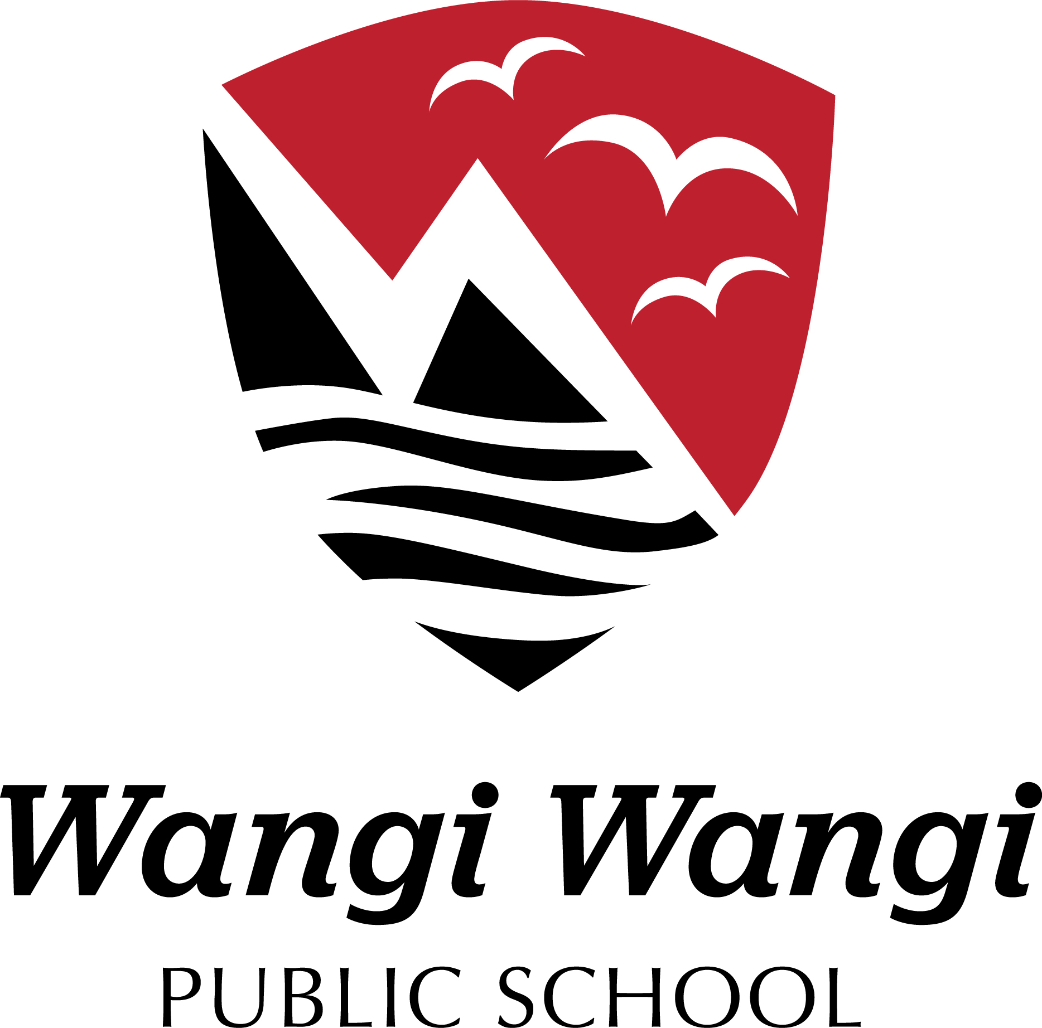Special Religious Education and Special Education in Ethics Participation Letter

A feature of the public education system in NSW is the opportunity to provide time in class for education in ethics, faith and morality from a religious or non-religious perspective at the choice of parents.

The school website [www.wangiwangi-p.schools.nsw.gov.au](http://www.wangiwangi-p.schools.nsw.gov.au) provides information on these options to support parent/carer choice.

A parent/carer may at any time notify the school in writing that they wish to change their decision. Students will continue the same arrangement as the previous year, unless a parent/carer has requested a change in writing.

If your preferred SRE or SEE option is not available please contact the approved provider. Students not attending SRE or SEE are given supervised alternative meaningful activities.

For more information about Special Religious Education (SRE) and Special Education in Ethics (SEE), including the list of approved providers, please visit: <https://education.nsw.gov.au/religion-and-ethics>

The following options are available at Wangi Wangi Public School. Please choose one.

SRE Options

□ Combined Christian SRE

Christian SRE is delivered by the Baptist Union of NSW [www.nswactbaptists.org.au](http://www.nswactbaptists.org.au) , who are authorised to deliver combined Christian SRE by the following approved providers: Anglican Diocese of Newcastle, Australian Christian Churches, Baptist Union of NSW, Catholic Diocese of Maitland-Newcastle, Lake Mac Evangelical Church (Morisset), Seventh-day Adventist Church North NSW Conference (Elermore Vale), The Salvation Army and Uniting Church in Australia (NSW/ACT Synod).

OR

**If you do not wish for your child to attend Special Religious Education, please select below**

□ Alternative meaningful activities.

Student name:       _____ Year:      __________

Signature of parent/carer: Date:

If you selected Special Religious Education or Special Education in Ethics, you confirm that, in doing so, you consent to the Department providing your child’s name to the nominated approved provider. The Department is required to obtain your consent under section 26 of the Privacy and Personal Information Protection Act 1998 (NSW) so that it does not have to comply with section 19, which would otherwise apply to prevent the Department from providing your child’s name.